Text file with information about Deltas

Table of:
Delta, Mc_SLN, Mp_SLN, sigma_LN, sigma_SLN, alpha_SLN, alpha_CC3, beta

Isatis runs

Unmodified version
- Monochromatic MF

Modified version
- Monochromatic MF
- Log-normal
  - Delta = 0.0, 0.1, 0.3, 0.5, 1.0, 2.0, 5.0
- Skew-lognormal
  - Delta = 0.0, 0.1, 0.3, 0.5, 1.0, 2.0, 5.0
- Critical collapse 3
  - Delta = 0.0, 0.1, 0.3, 0.5, 1.0, 2.0, 5.0

(22-23 in total)

START OF PROGRAM:

Imports:
- numpy
- matplotlib.pyplot
- matplotlib
- preliminaries

Plotting style code

____________________________________________________________________________

METHODS:

- constraint_Carr(mc_values, m_mono, f_max, mf, params):
  - Calculate constraint on f_PBH for an extended mass function, using the method from 1705.05567.
  - mc_values: Array-like
    - Characteristic PBH mass (m_c for a (skew-)lognormal, m_p for CC3).
  - m_mono: Array-like
    - Masses at which constraints for a monochromatic PBH mass function are evaluated.
  - f_max: Array-like
Constraints obtained for a monochromatic mass function.
  - mf: Function
    - PBH mass function.
  - params: Array-like:
    - Parameters of the PBH mass function
  - Returns:
    - f_PBH : Array-like
      - Constraints on f_PBH.

  - f_pbh = []
  - for m_c in mc_values:
    - integral = np.trapz(mf(m, m_c, *params) / f_max, m_mono)
    - if integral == 0:
      - f_pbh.append(10)
    - else:
      - f_pbh.append(1/integral)

- envelope(constraints)
  - Calculate the tightest constraint at a given mass, from a set of constraints.
  - Constraints: Array-like
    - Constraints on PBH abundance. All should have the same length and be evaluated at the same PBH mass.
  - Returns
    - tightest: Array-like
      - Tightest constraint, from the constraints given in the input.
____________________________________________________________________________

Checks:

Compare method from 1705.05567 to analytic calculations for some simple test cases where the constraint is calculable exactly.

f_max = const.
- Works well for a log-normal with sigma=0.5, so long as the range of PBH masses M is an order of magnitude wider than the range of the values of M_c chosen. For larger sigma, a wider range of PBH masses M is required
- Explain this behaviour
  - For f_max=const., the integral in Eq. (12) of 1705.05567 becomes equivalent to calculating the integral of the mass function over all masses. At the upper and lower end of the range of M_c values, the integral is not evaluated very accurately since a significant portion of the mass range is not included. To obtain f_max = constant exactly, one needs to integrate from 0 to infinity.
- Intuitively, why does a constant f_max => constant f_PBH for an extended MF?
  - If a constraint is independent of the PBH mass, that means it applies to PBHs regardless of their mass or mass distribution. So there is no difference between the constraint if one applies an extended mass function.

f_max ~ 1 / M
- Visually, result matches very closely with analytic calculation, even if the range of PBH masses M is chosen to be the same as the range of values of M_c chosen, for a log-normal with sigma in the range (0.5-4)
- Why does this test work so much better than the constant f_max test, when the range of PBH masses M is chosen to be the same as the range of values of M_c chosen?
  - Because I am not comparing like for like.
    - In the first test, I did the analytic integral in Eq. (12) of 1705.05567 assuming the integration limits (M_1, M_2) tend to (0, infinity).
    - For the f_max ~ 1/M case, I explicitly calculated the integral with undefined limits (M_1, M_2), which means that my output is simply checking well the numerical integration method np.trapz() matches with the exact value.

Check envelope() method and isatis_reproduction.py by comparing results with those obtained using Isatis:
- Test outline
  - Load the data produced by running isatis_reproduction.py for each energy bin, and use the envelope() method to calculate the tightest constraint from each instrument at each PBH mass
  - Compare to result obtained directly using Isatis.
- Test passes excellently for the monochromatic MF constraint obtained using the modified version of Isatis.
  - (in plot, solid lines are the direct Isatis calculation. Crosses are the results from isatis_reproduction.py combined with the envelope() method).

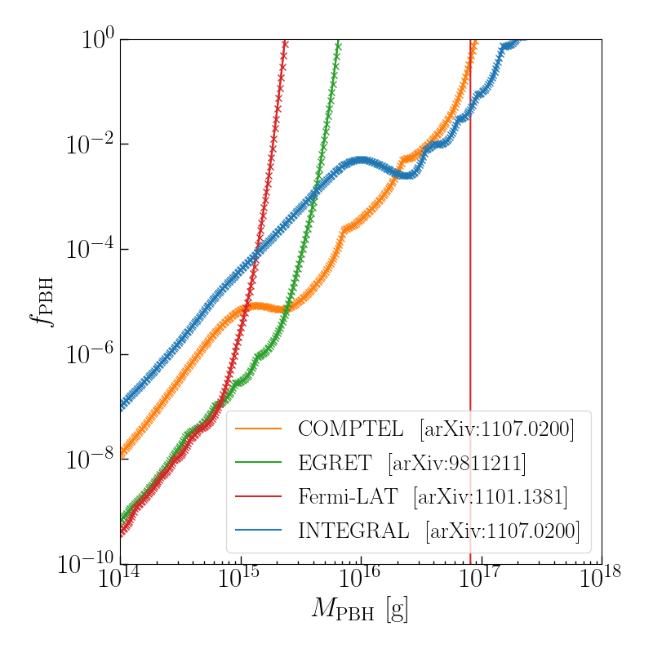

Compare Isatis method to method from 1705.05567 (using the envelope of the Isatis constraints) for:
- LN
- SLN
- CC3

Include version using the envelope of the constraints as f_max(), and a version using the constraint from each bin individually for f_max().

Envelope of constraints as f_max():
- For f_max, use load_results_Isatis() to load the monochromatic MF constraint from Isatis

Using the constraint from each bin individually for f_max():
- For each instrument:
  - Load data from generated using isatis_reproduction.py (an array of arrays, each sub-array being a constraint for a particular energy bin)
  - For each sub-array (i.e. each energy bin):
    - Calculate a constraint f_PBH for that bin, using the Carr et al. method, evaluated at M_c
  - Use the envelope() method to evaluate the tightest constraint for an extended MF at each M_c

Make into a method? To make this part of the code easier to evaluate for different mass functions?

Results
Solid line: Isatis constraints
Crosses: Carr et al. method

Delta=0.0
Very good agreement (no noticeable difference), at all M_c and for all instruments

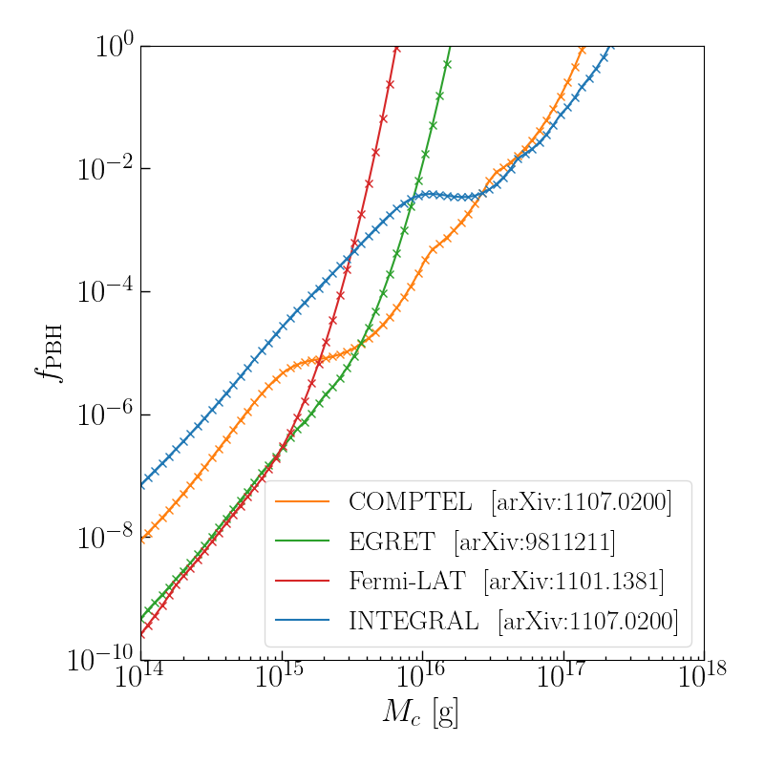

Delta=2.0

Use Delta=2.0 since this has the widest MF for any of the lognormal MF values given in Table II of 2008.03289.

Very good agreement for f_PBH < 1
- The only noticeable difference is for the Fermi-LAT constraint, close to f_PBH = 1
Differences at large M_c (of f_PBH) become apparent when zooming out to include f_PBH > 1
- Difference noticeable for Fermi-LAT and EGRET
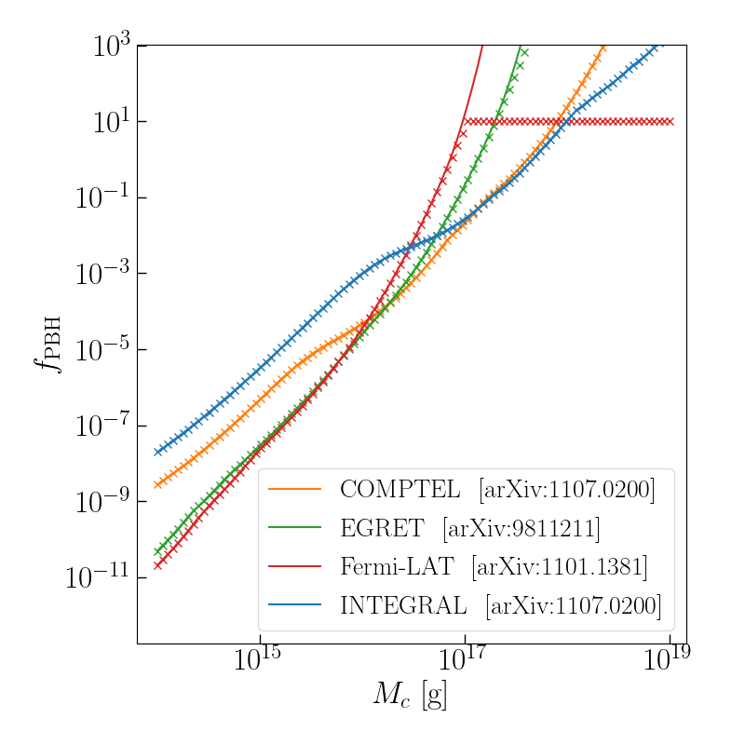
- For Fermi-LAT, the results where f_PBH = 10 correspond to where the integral in the Carr et al. method is calculated as zero.
- Understand if this is significant

Possible sources of difference:
- One source of difference I’m aware of is that the range of PBH masses obtained for a monochromatic MF is not the same for the constraints obtained using Isatis and the method from 1705.05567
  - Two ways to remove this source of difference:
    - Calculate the constraint from Isatis for a log-normal MF, with the range and number of PBH masses matching that of the Carr et al. method
    - Calculate the monochromatic MF constraint using isatis_reproduction.py, with the range and number of PBH masses matching that of Isatis

  - Calculate the constraint from Isatis for a log-normal MF, with the range and number of PBH masses matching that of the Carr et al. method
    - To address: not saving the BlackHawk output file in the ./results folder
      - This arose because the string in the first line of the BlckHawk parameters file (‘destination folder’), which determines where to save the file, was too long (>42 characters)
      - To distinguish the results obtained using the mass range as used in 1705.05567, I appended a string “test_mass_range”
      - To avoid this error, I have removed the underscores, so am now appending “testmassrange”
    - To address:
      - Why is the test_extended_mass version not saving a parameters file for Isatis (I had to create and run this manually for the test shown)
        - Unclear. Running the code on Monday, the parameters file saved okay.
        - The “output” in the Isatis parameters file is truncated to a 35 character string, so the results file ends with “..._testmassra.txt.”
          - To avoid causing conflict between the output and input results, I will re-word the appended string “test_range” to make it <= 35 characters
      - Why is the Isatis results file for Delta=0.0 empty? (I think I may have aborted a run when re-running this)
        - Delete the existing extended MF files, and re-run them to check

Delta=2.0 (preliminary, should re-run)
Very good agreement for f_PBH < 1
- The only noticeable difference is for the Fermi-LAT constraint, close to f_PBH = 1

Differences at large M_c (of f_PBH) disappears when zooming out to include f_PBH > 1

Difference noticeable for Fermi-LAT and EGRET
- For Fermi-LAT, the results where f_PBH = 10 correspond to where the integral in the Carr et al. method is calculated as zero.
- Understand if this is significant

An additional note is that I have only changed the range of PBH masses, not the number of PBHs simulated for the Isatis constraints.
- Number of PBHs simulated for Isatis constraints = 10000
- Number of masses at which the monochromatic MF constraint is calculated (for the 1705.05567 method) = 1000

Conclusion: The difference apparent between the Isatis constraints and the method from 1705.05567 disappears when using the same PBH mass range for both sets of constraints.

To do:
- Think about which version of the constraints is more accurate

Plot shows comparison of constraints obtained from Isatis, using the same PBH mass range as for the constraints obtained using the method from 1705.05567.
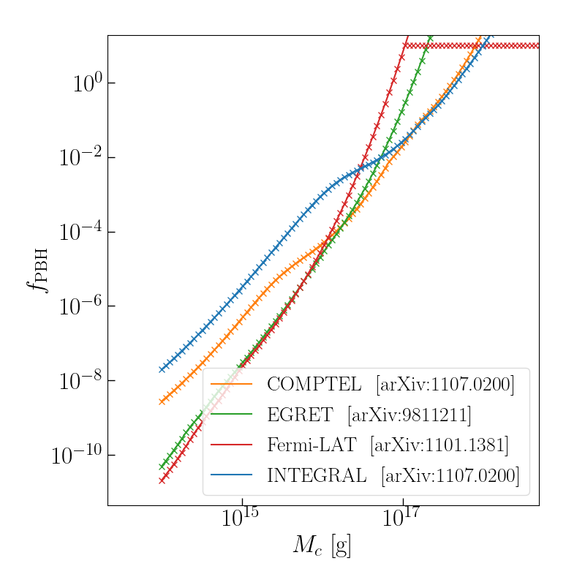
Relative acccuracy of the constraints
- The 1705.05567 method constraints are obtained for the same PBH mass range (with 1000 PBHs) regardless of the characteristic mass (M_c or M_p) or other parameters (e.g. standard deviation sigma) of the mass function.
- This Isatis constraints are likely to be more accurate for two reasons:
  - They include a mass range which includes all masses for which the mass function (divided by the peak value of the MF) is larger than a cutoff value (currently set at 1e-5)
  - The total number of PBH masses included in this narrower range is larger than the 1705.05567 method constraints (10000 compared to 1000)

Possible changes to improve accuracy of constraints
- It may be possible to more accurately calculate the mass range over which an integral over the mass function is non-negligible, by using the relation between the PBH mass and emission rate.

Test results (31/3):

Test: constant constraint from monochromatic MF

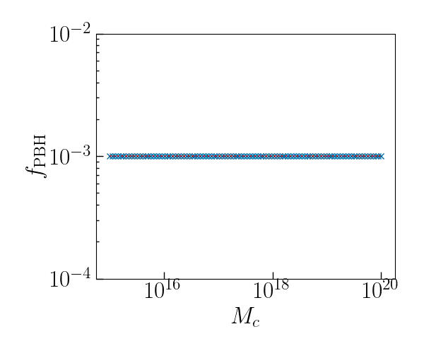
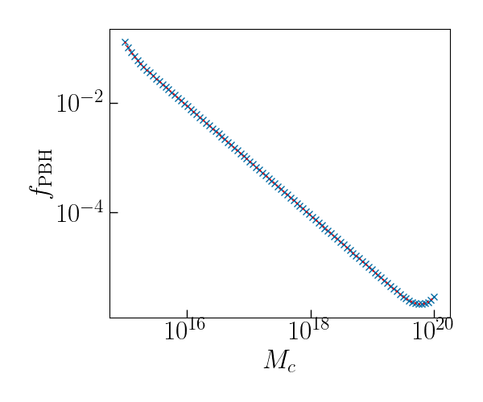
Test: linearly decreasing constraint from monochromatic MF

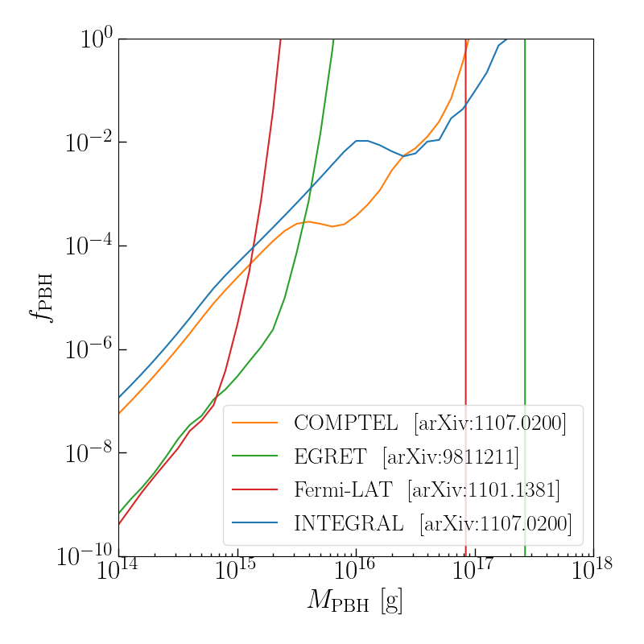
Plot results for a monochromatic mass function, obtained using Isatis, and compare to the results shown in Fig. 3 of 2201.01265.

Plot results for a monochromatic mass function, obtained using isatis_reproduction.py, and compare to the results shown in Fig. 3 of 2201.01265. Includes highest-energy bin. Includes test of the envelope() function.
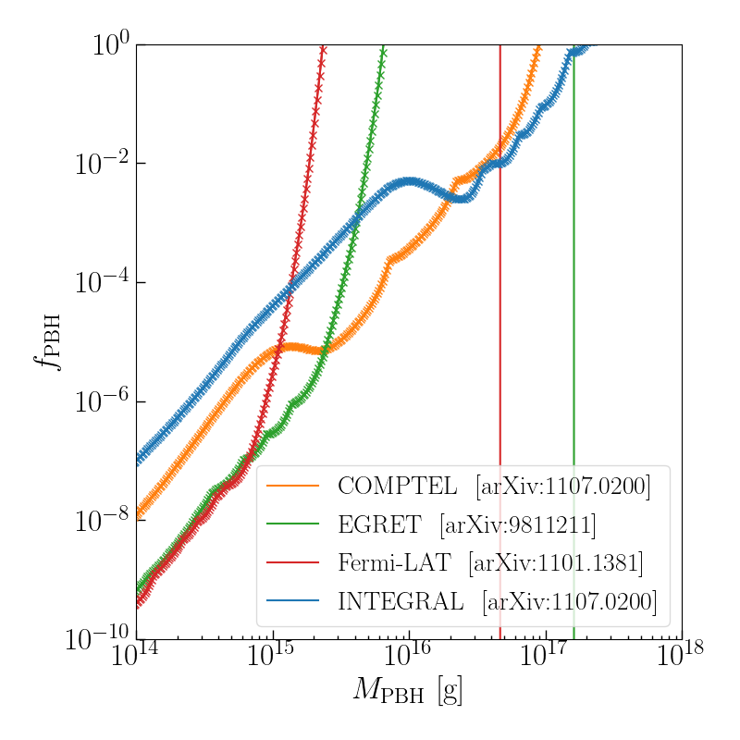

Plot results for a log-normal mass function, obtained using Isatis, and compare to the results obtained using the method from 1705.05567, from the envelope of constraints from each energy bin. Using the modified version of Isatis. Both forms of the constraint calculated using the same range and number of PBH masses.
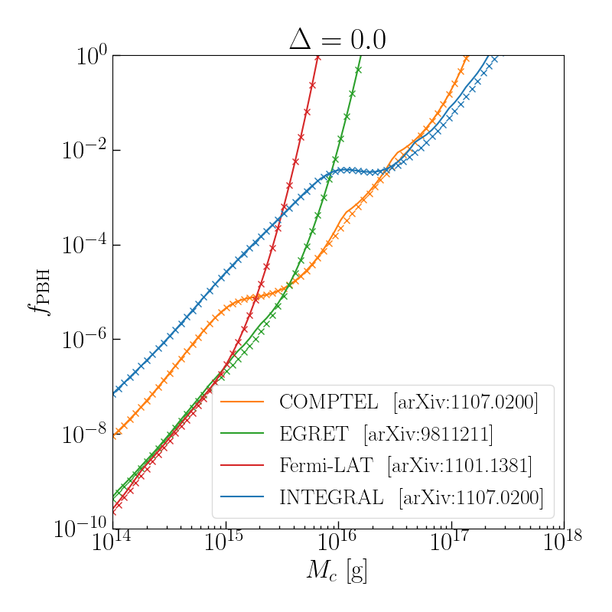
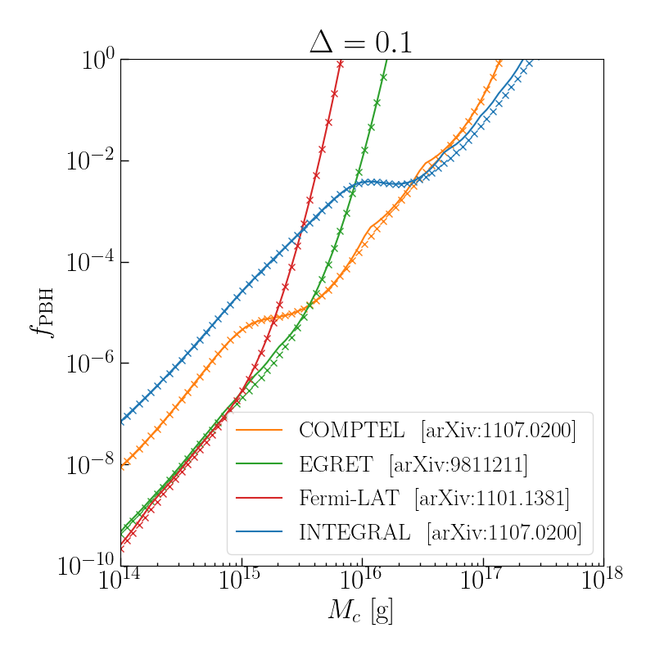
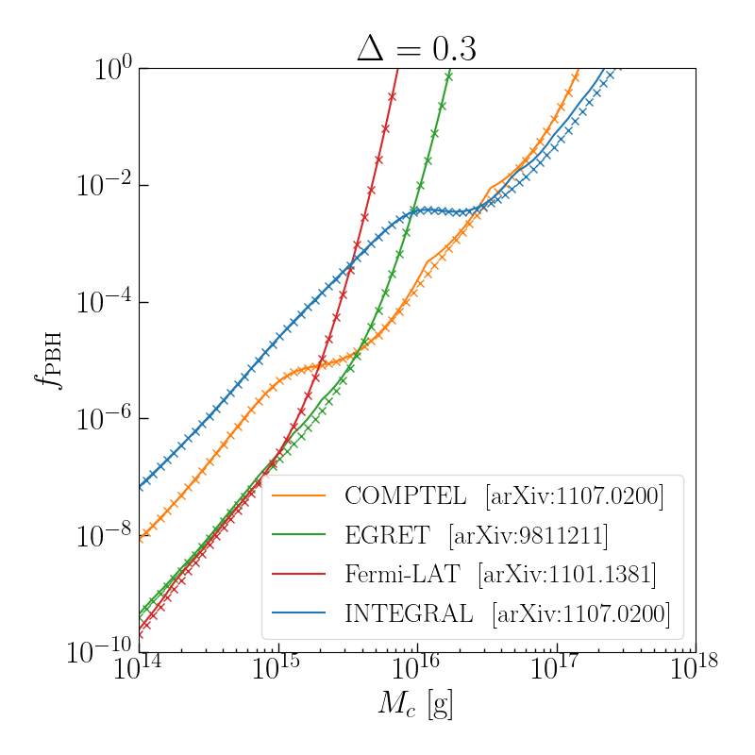
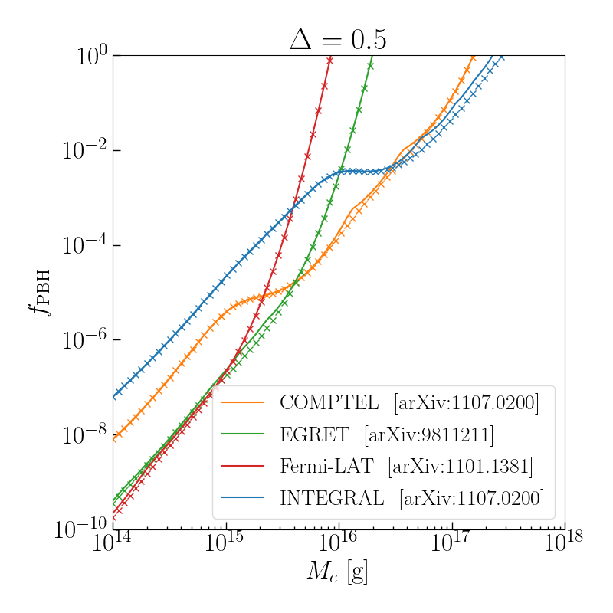

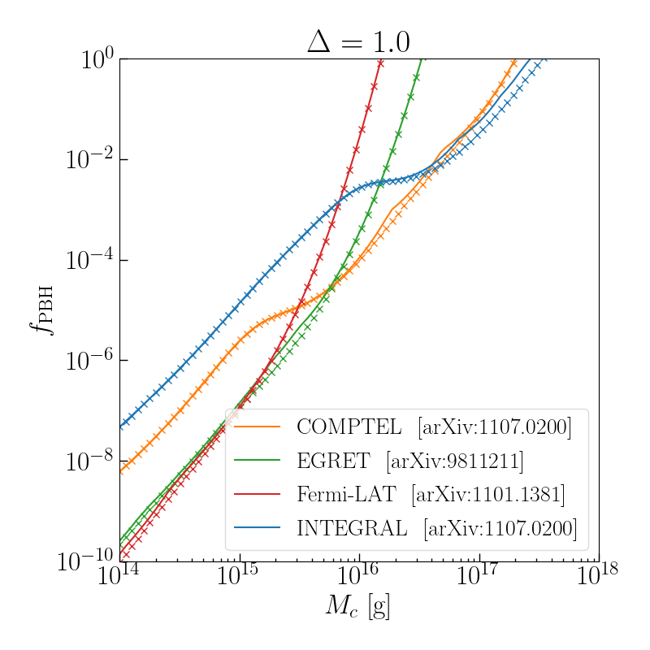
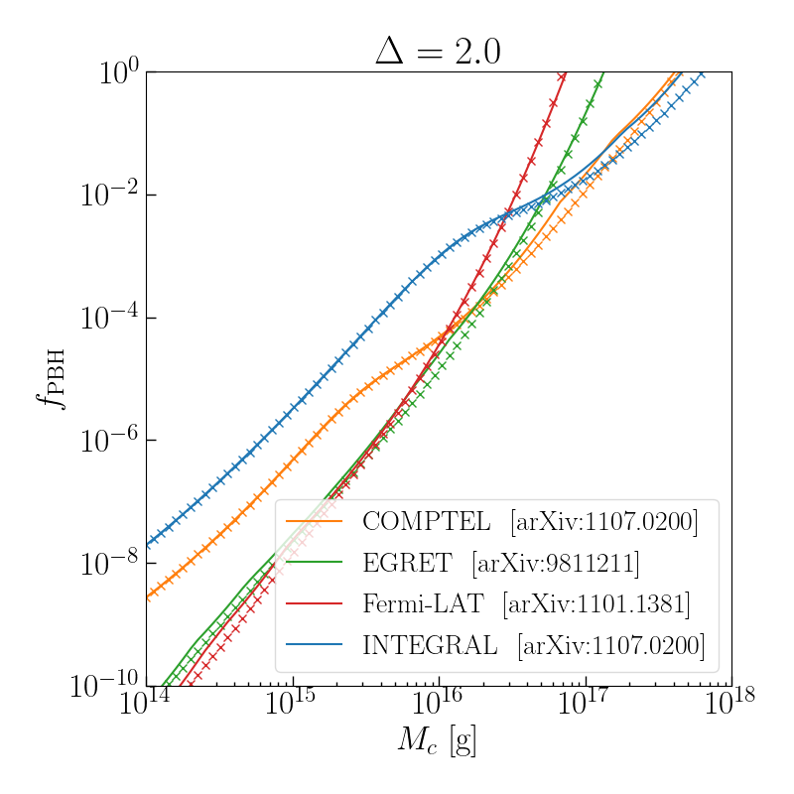

Plot results for a log-normal mass function, obtained using Isatis, and compare to the results obtained using the method from 1705.05567, using the constraint from each energy bin separately. Using the modified version of Isatis. Both forms of the constraint calculated using the same range and number of PBH masses.

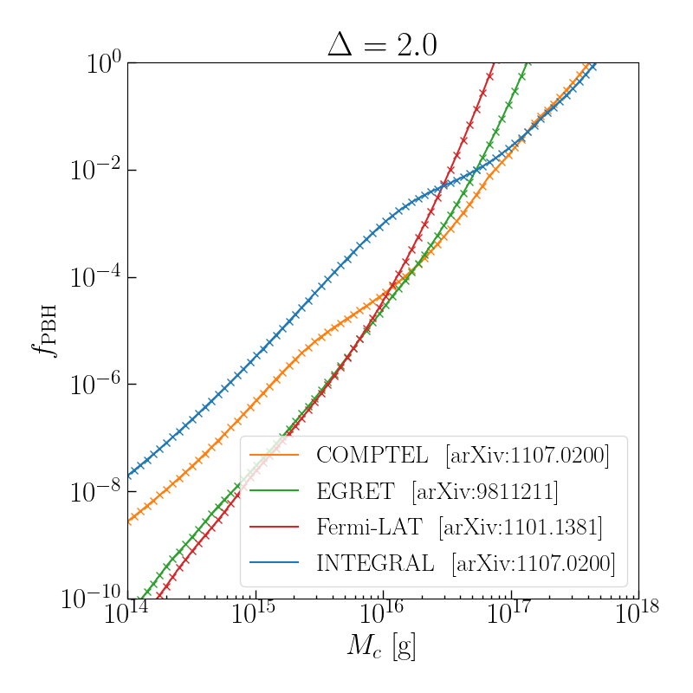

4/4

Test the Carr et al. method implementation for the LN evaporation constraints, only including the PBH mass range where f_PBH < 1 and a limited mass range (m > 1e15g).

Let m_min_mono, m_max_mono = Minimum and maximum monochromatic MF masses to include constraints from 1705.05567.

Sanity check

The solid line denotes constraints obtained using Isatis. Crosses obtained using the method from 1705.05567, with monochromatic MF constraints produced using isatis_reproduction.py.

Include the entire monochromatic MF range (m_min_mono = 1e11g, m_max_mono = 1e21g) for which I can calculate the constraints using the method from 1705.05567
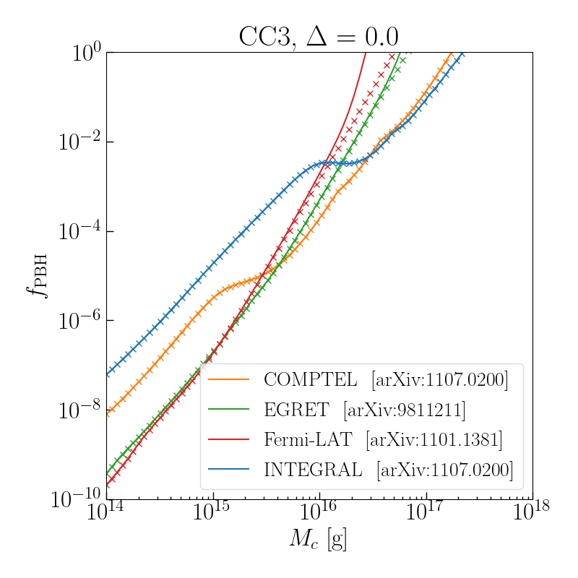
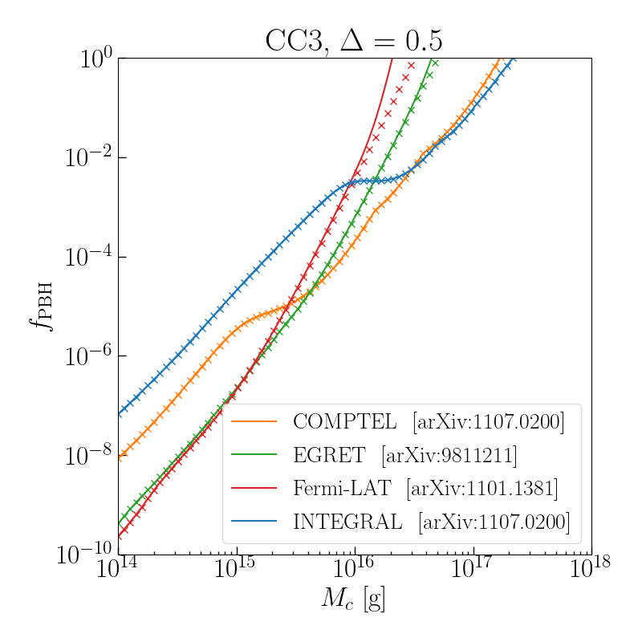
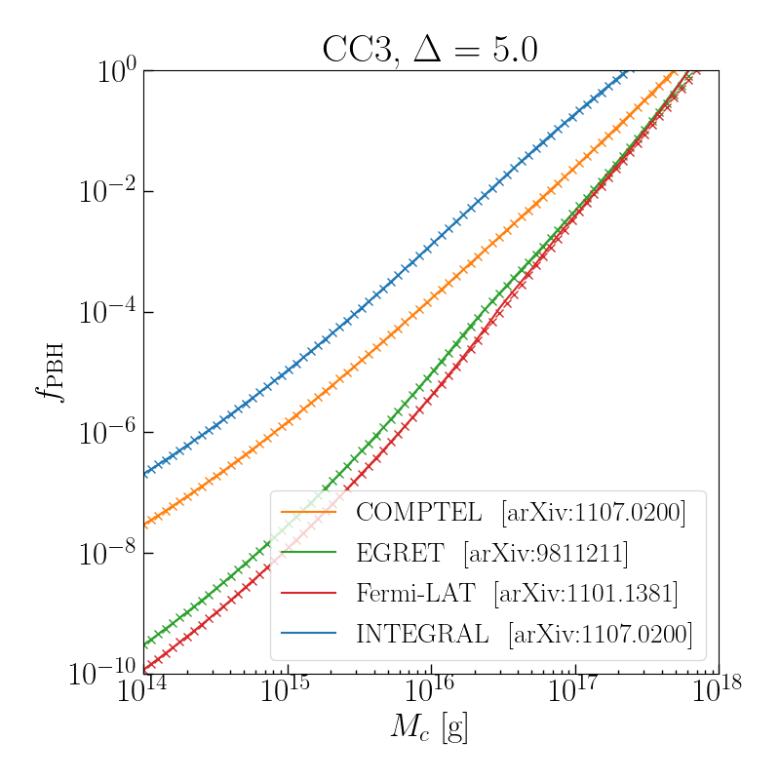

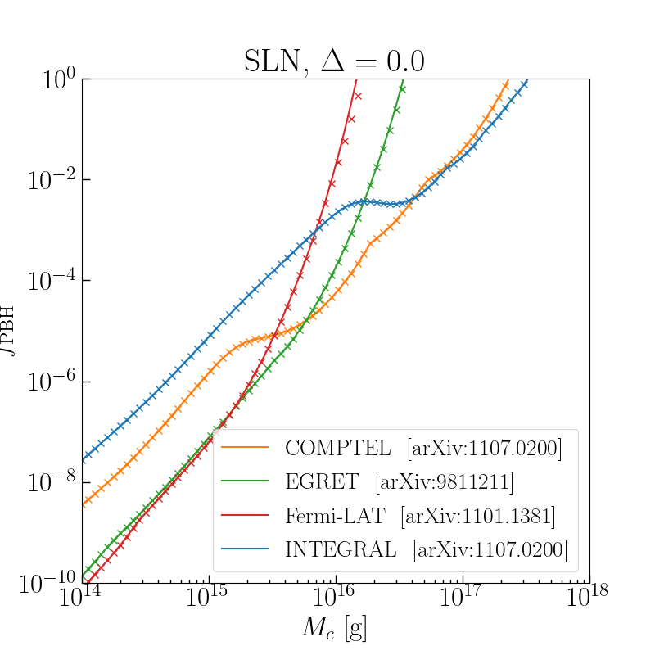
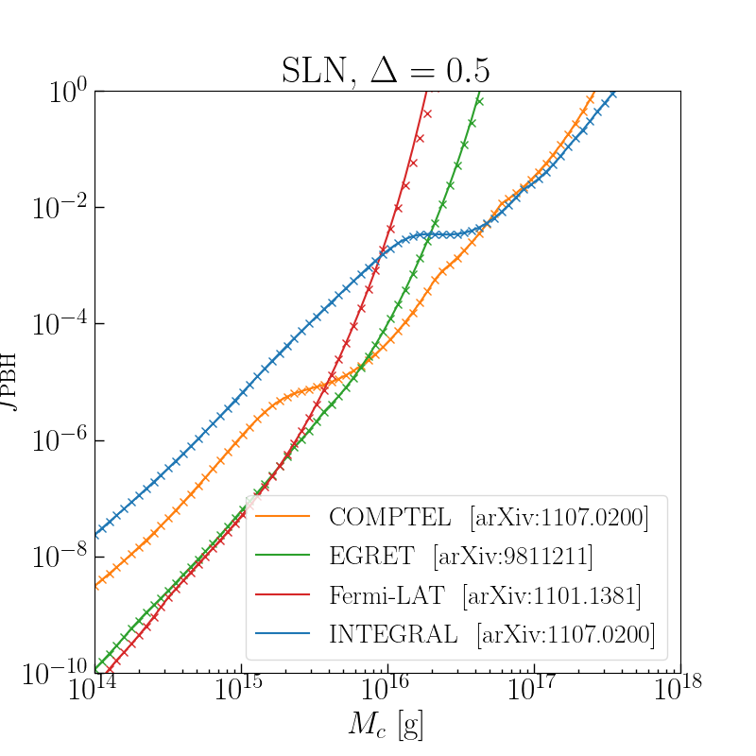
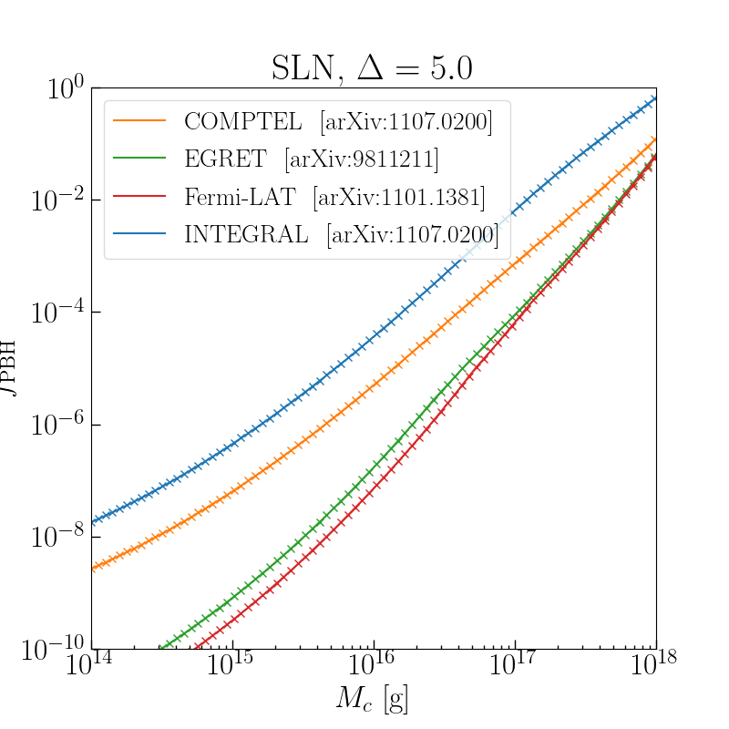

The results differ at the largest masses:
- The most relevant difference is for the tightest of the four constraints. For the CC3, this differs by of order 10% between the two methods. Perhaps surprisingly, the method from 1705.05567 places a tighter constraint than Isatis.
- My question is how can this be compatible with the convergence tests. For m_c = 1e19g, I found the Isatis results agreed to within 10% of the most accurate calculation using a cutoff of 1e-4 in psi/psi_max. The fact that the constraint using the 1705.05567 method is more than 10% tighter implies the PBH mass range used in the Isatis range is insufficient

Test:
- In constraint_Carr(), change the value of f_PBH calculated if the integrand appearing in Eq. (12) of 1705.05567 equals zero.
- No effect, since this affects the output in the range where f_PBH > 1 only.

- For Delta=5.0, is m = 1e21g in the range for which psi(m=1e21g) / psi_max > 1e-4?
- In preliminaries.py, find the minimum value of m_c / m_p for which psi(m=1e21g) / psi_max > 1e-4

Results:
SLN: mc_min = 1.5e+18g
CC3: mc_min = 4.1e+17g

The ~10% difference seen in the CC3 MF results can be explained as being due to an upper value of m = 1e21g being insufficient to include the full mass range.

The SLN MF results at m_c~1e18g differ from those obtained using Isatis with a cutoff at 1e-4 by ~3% (EGRET) and ~8% (Fermi-LAT).

To do:
- Re-run isatis_reproduction.py with 1000 steps between 1e11-1e22g (for the SLN and CC3, 1e22g should be
sufficient to include all results with m_c > 1e18g, m_p > 1e18g).

- Save files as “mono_E500_wider” in the BlackHawk results folder, the constraints on f_PBH as “fPBH_GC_%s_widefPBH_GC_%s_wide” [%s gives the instrument]

- Took the following steps:
- Re-ran isatis_runner_mono.py with PBH mass range logarithmically spaced between 1e11-1e22
  - BlackHawk files saved as “mono_E500_wider_”
- Re-ran isatis_reproduction.py
  - Changed the BlackHawk files to use from “GC_mono” to “mono_E500” (the results had been loading the BlackHawk files produced during my abortive attempt to use a combination of Hazma and PYTHIA hadronisation codes)

Results
See Pictures/Apr 23/Carr_test

The solid line denotes constraints obtained using Isatis. Crosses obtained using the method from 1705.05567, with monochromatic MF constraints produced using isatis_reproduction.py.

m_min_mono = 1e14g, m_max_mono = 2e17g
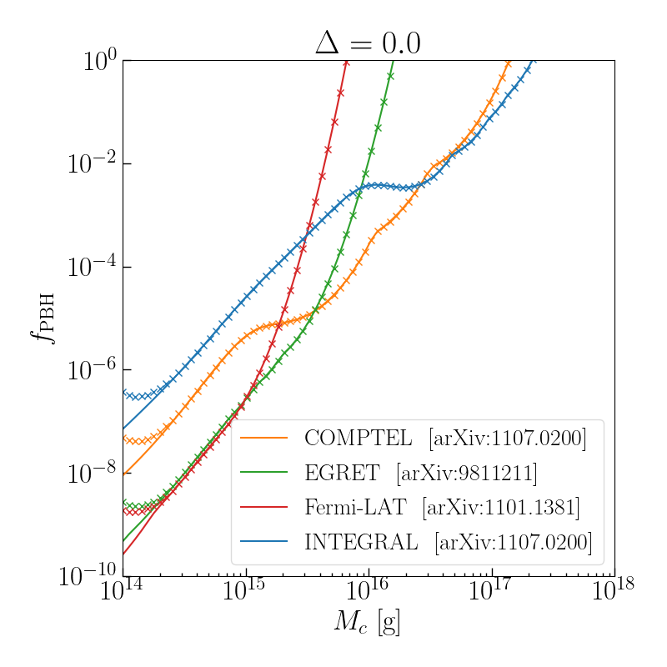
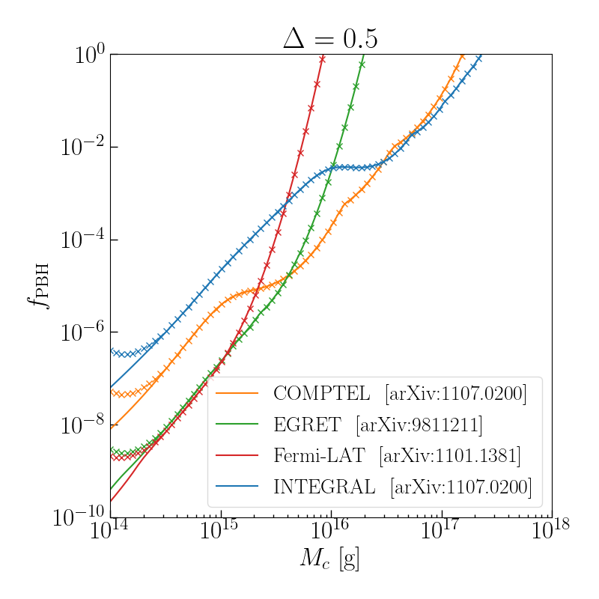
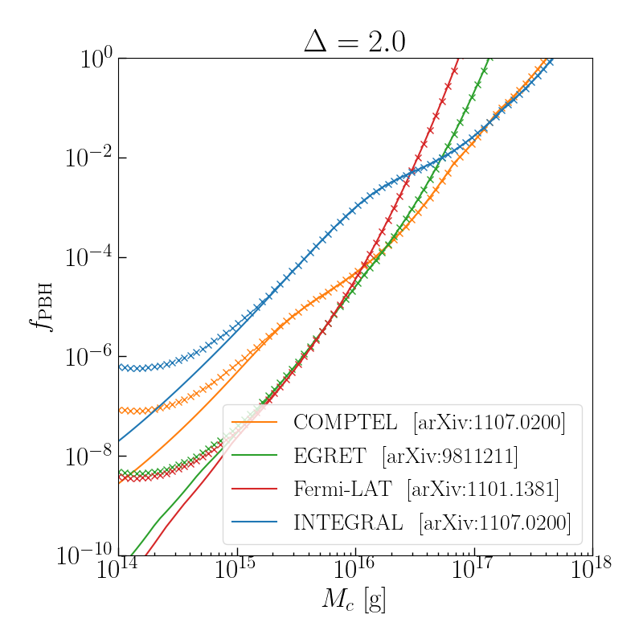

m_min_mono = 1e15g, m_max_mono = 2e17g
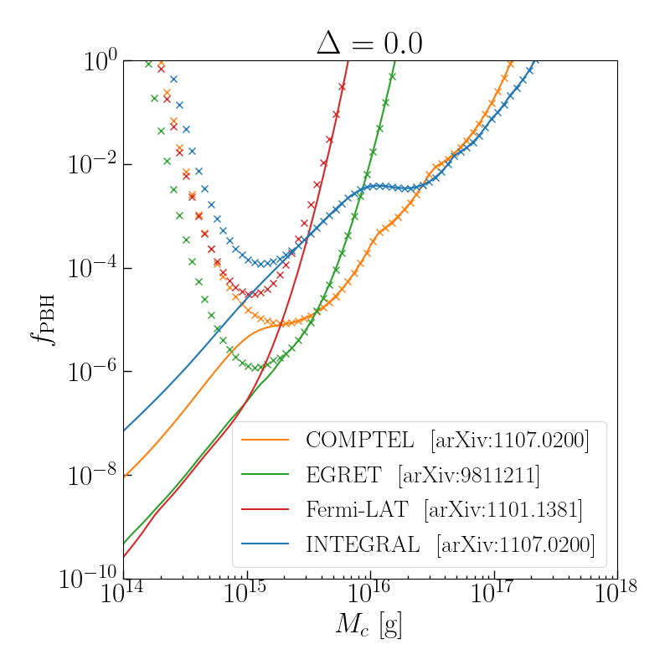
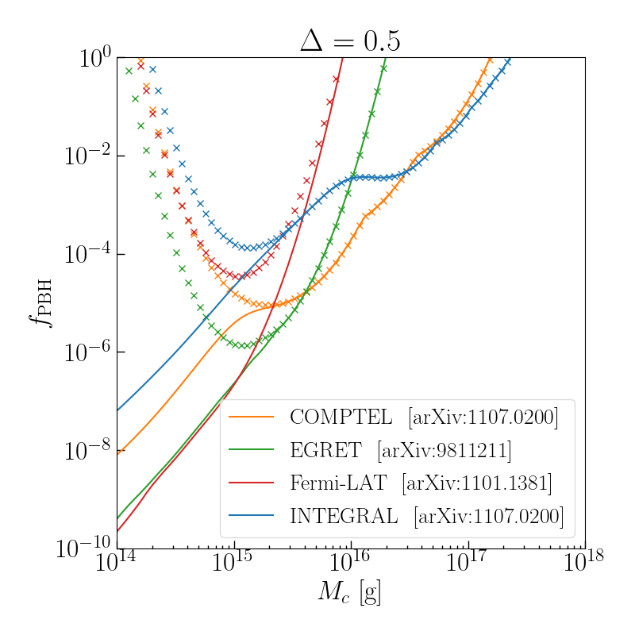
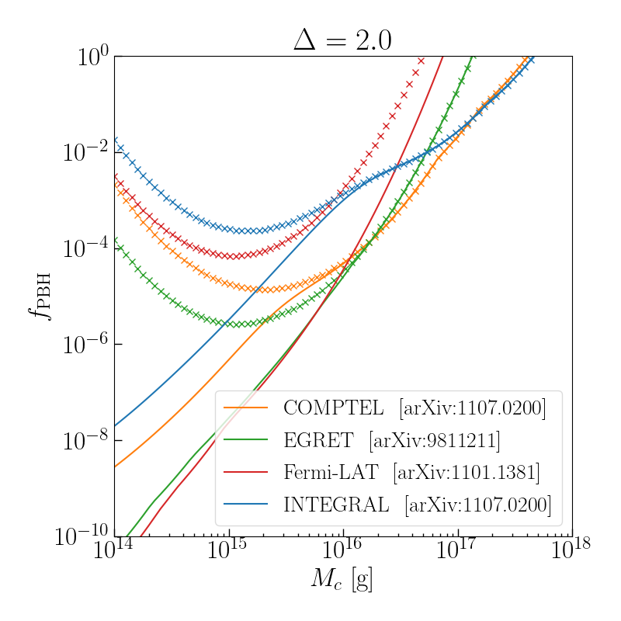

These results suggest that, for Delta <= 2.0:
- The effect of excluding constraints at higher masses (where f_PBH >1) is small or negligible for most of the constraints (the exception is the Fermi-LAT constraints fro Delta=2.0)
- The effect of excluding constraints at lower masses becomes significant at:
  - m_c ~ 3* m_mono_min (Delta=0.0, Delta=0.5)
  - m_c ~ 10 * m_mono_min (Delta=2.0)

To do: check for SLN and CC3 with Delta=5.0

Effect of changing constraint on PBHs with masses m < 5e14g:
Tightest constraint (i.e. setting the constraint equal to the value it has at 5e14g at lower masses):

No significant effect on Delta < 2.0

Results for the value of the peak mass m_p closest to where f_PBH = 1 (tightest constraint).
- SLN: m_p = 3.2e17g, constraint on f_PBH is ~3% weaker than not including evaporation at all (0.89 vs 0.93)
- CC3: m_p = 4.9e17g, constraint on f_PBH is ~50% weaker than not including evaporation at all (0.43 vs 0.80)

TO DO: CHECK THIS IS WORKING CORRECTLY, by printing things
Check this approach works as expected:
- Find which index of the monochromatic PBH masses array m_mono_values = np.logspace(11, 22, 1000) has a value just above 5e14g.
  - print(np.argmax(m_mono_values_init > 5e14)) = 336
  - m_mono_values[335] = 488302208687788.5
  - m_mono_values[336] = 500840798984821.25
- Print a few of the constraint values from the monochromatic MF bins, and compare to the values obtained for the 336th line in the constraints file obtained from isatis_reproduction.py

Weakest constraint (i.e. setting f_max to a large number for m < 5e14g):

Results for the value of m_c / m_p closest to where f_PBH = 1 (tightest constraint).
- SLN: m_p = 3.2e17g, constraint on f_PBH is ~4% weaker than not including evaporation at all (0.89 vs 0.93)
- CC3: m_p = 4.9e17g, constraint on f_PBH is ~50% weaker than not including evaporation at all (0.88 vs 0.43)

Results appear insensitive to the form of the constraint below 5e14g, but they are different if one does not include PBHs with masses < 5e14g

